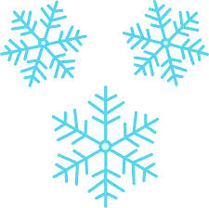



**Winter Fest 2013**

***Tuesday, December 17th from 2-4 pm***

***Cost:*** $3 for entry (bring money for food, drinks, and snacks)

***Activities Include but not limited to:***

Free Throw Contest



Craft Table

Wrap Your Teacher Contest

Movie

Pin the Beard on Santa

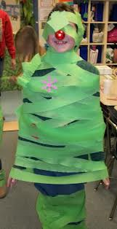

Snowball Toss

And Many More!!!



Brought to you by:

Student Council