Because Hunger Doesn’t Take
A Break on the Weekends

Please join us for a
Spaghetti Dinner
ALL ticket sales/donations go to Blessings in a Backpack Dearborn.
$80 feeds a child on the weekend for an entire school year!
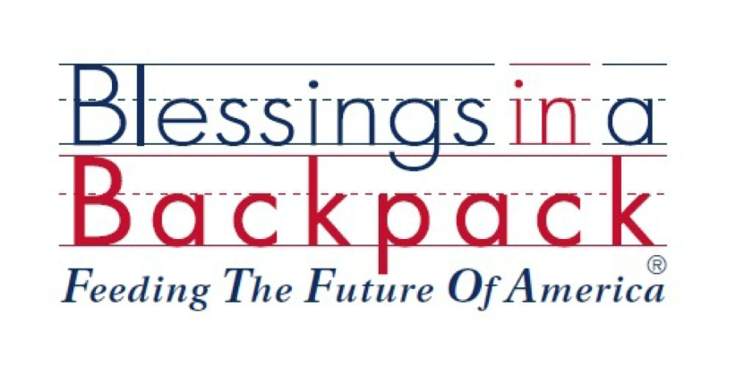
Friday, February 5th - 5 pm to 7:30 pm

Good Shepherd United Methodist Church
1570 Mason at Monroe, Dearborn

Dinner includes: spaghetti (choice of meat or vegetarian sauce), salad bar, Panera bread, homemade desserts, beverage choice
Adults: $8.00
Children 6 to 12: $3.00
5 and under: free
Carry-outs available

