It’s easy to access the online tools you need!

- Register/Log In
Log in at hap.org using your HAP ID and password. If you have not yet registered, select Register Now. After registering, you will be re-directed to the hap.org home page to log in.

- Click on iStrive for Better health section in order to take the health assessment and participate in healthy lifestyle programs and challenges. On Health Risk Assessment new members must agree and provide an optional e-mail address.

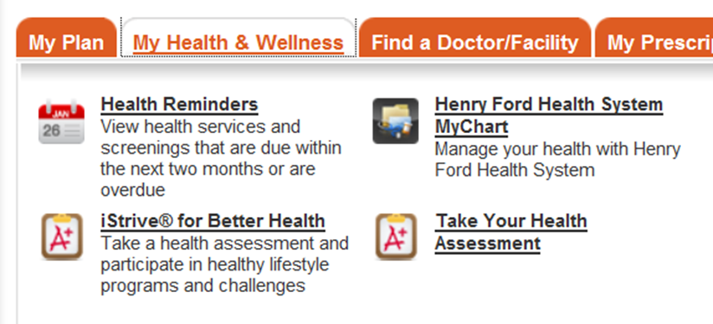
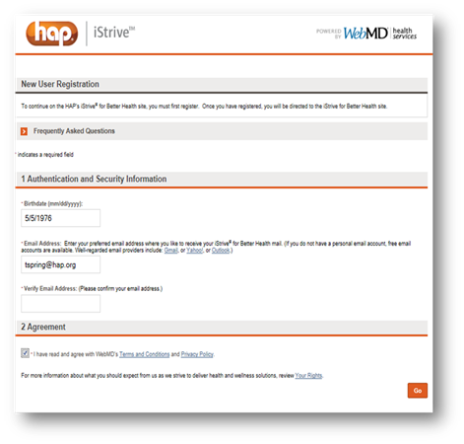

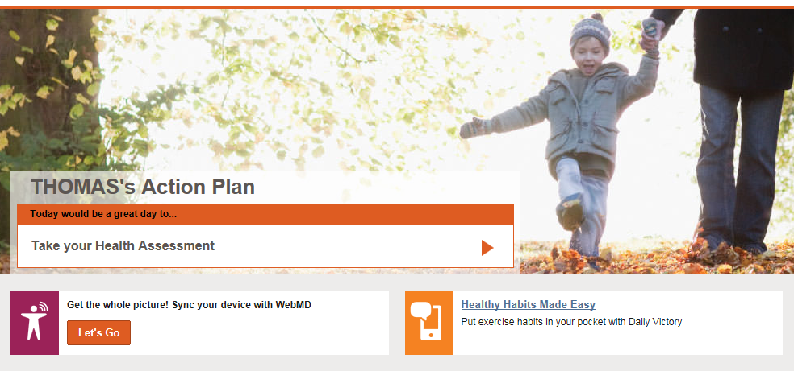
- Start the questionnaire. Click on Start Your Health Assessment to begin.

