Sellers Name________________________________Phone #________________________

Email_______________________________

Orders must be dropped off to Amy Fradkin with cash or checks payable to **STEM PTA** by Friday, November 13. Orders will be delivered to O.L. Smith on Monday, November 23 and must be picked up on that day. Please call or text Amy Fradkin at 313-598-3553, with any questions.



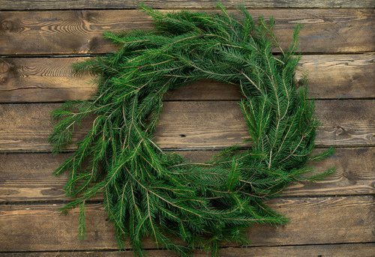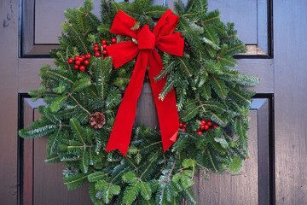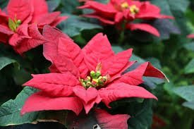

**Schwartz’s Greenhouse has partnered with O.L. Smith Middle School to help bring holiday cheer to your home. Poinsettias, door wreaths and gift cards are available. Thank you for supporting our school and Schwartz’s Greenhouse!**

**Poinsettias offered in red and white single pots, covered in gold foil:**

Mini (1 plant, 3-5 blooms) $ 6

Single (1 plant 5-7 blooms) $10

Double (2 plants 8-14 blooms) $18

**Plain Fresh Door Wreath (No cones or bows)**

12” Wreath (approx. finish size 18-20”) $20

16” Wreath (approx.. finish size 25-27”) $25

**Decorated Wreaths (red velvet bow, 3 pinecones)**

12” Wreath (approx. finish size 18-20”) $30

16” Wreath (approx.. finish size 25-27”) $35

**Schwartz Nursery Gift Cards in quantities of $25**

|  |  |  |  |  |  |  |  |  |  |  |  |  |  |  |
| --- | --- | --- | --- | --- | --- | --- | --- | --- | --- | --- | --- | --- | --- | --- |
| **Name** | **Poinsettias** | | | | | | **Door Wreaths** | | | | **$25**  **Gift Card** | **Total** | **Paid** | |
| **Mini $6** | | **Single $10** | | **Double $18** | | **Plain** | | **Decorated** | |
| **Red** | **White** | **Red** | **White** | **Red** | **White** | **12” $20** | **16” $25** | **12” $30** | **16” $35** |
|  |  |  |  |  |  |  |  |  |  |  |  |  |  |
|  |  |  |  |  |  |  |  |  |  |  |  |  |  |
|  |  |  |  |  |  |  |  |  |  |  |  |  |  |
|  |  |  |  |  |  |  |  |  |  |  |  |  |  |
|  |  |  |  |  |  |  |  |  |  |  |  |  |  |
|  |  |  |  |  |  |  |  |  |  |  |  |  |  |
|  |  |  |  |  |  |  |  |  |  |  |  |  |  |
|  |  |  |  |  |  |  |  |  |  |  |  |  |  |
|  |  |  |  |  |  |  |  |  |  |  |  |  |  |
|  |  |  |  |  |  |  |  |  |  |  |  |  |  |
|  |  |  |  |  |  |  |  |  |  |  |  |  |  |
|  |  |  |  |  |  |  |  |  |  |  |  |  |  |
| **Totals** |  |  |  |  |  |  |  |  |  |  |  |  |  |