TRIP DATES

The Alpena trip is set for Thursday, May 28 - Friday, May 29, 2020.

TRIP COST AND PAYMENTS

The cost of the trip is $445.00 per student. This amount covers the cost of transportation (chartered bus), food (5 meals), lodging, (1 night), trip planning, and all admissions. Other included services 24 hour emergency service, name tags, and trip booklets. In short, all student expenses except spending money will be covered by the trip cost.

The $445.00 trip cost will be collected in three installments:
October 01, 2019: $175.00 (to Ms. Fryzel)
February 24, 2020: $175.00
April 21, 2020: $95.00

PLEASE MAKE CHECKS PAYABLE TO CORPORATE TRAVEL.

There will be an additional $10.00 payment in March for other trip necessities.

* TIMELY PAYMENTS ARE VERY IMPORTANT FOR PROCESSING TO
TAKE PLACE.

CANCELLATION POLICY

Corporate Travel includes a trip cancellation process in the price of the trip. Please read the included policy carefully.

From the date of the deposit to 1/29/2020 $50.00 per seat penalty
1/30/2020 to 2/28/2020 $135.00 per seat penalty
2/29/202 to 3/29/2020 $265.00 per seat penalty
60 days or less NO refund

CHAPERONES

Teachers plan to serve as leaders for this trip. We will also be taking 4-5 parents. We want to leave as many seats available for students as possible, so we will take only 4-5 parents. Unlike in years past, chaperones will NOT be on a first-come-first served basis, but on the need for dads as well as moms. Also, consideration will be given to parents who have not traveled with us in the past so as to give new parents an opportunity to travel with us. If you are not willing to allow your child to travel without you, this may not be the trip for you. The parent cost for the trip is $465.00.

The $465.00 trip cost will be collected in three installments:
October 01, 2019: $175.00 (to Ms. Fryzel)
February 24, 2020: $175.00
April 21, 2020: $115.00
PLEASE MAKE CHECKS PAYABLE TO CORPORATE TRAVEL.

TRIP DEPARTURE MEETING

A departure meeting will be scheduled in May. Student and guardian attendance at this meeting is mandatory.

TRIP RULES

School rules apply on this trip. A set of trip rules that covers areas such as bus behavior, bedtimes, etc. will also apply.

FIRST-COME, FIRST-SERVED

We are traveling by chartered bus. These busses hold 45 passengers. We expect to take only full buses. Students are taken on a first-come, first-serve basis. There will be a waiting list in the event that one is needed. Your first payment and registration forms reserve your seat. We can NOT take verbal promises.

TO SIGN UP

To register students, please follow the steps below:

1. Read all information sent home.

2. Fill out and sign the following forms:
a. Trip enrollment form
b. Student eligibility form (front and back)

3. Turn in the two (2) forms above to Ms. Fryzel by October 1, 2019. Along with a check or money order for $175.00
made out to CORPORATE TRAVEL.

If possible, paying the full amount in the first payment would be greatly appreciated!

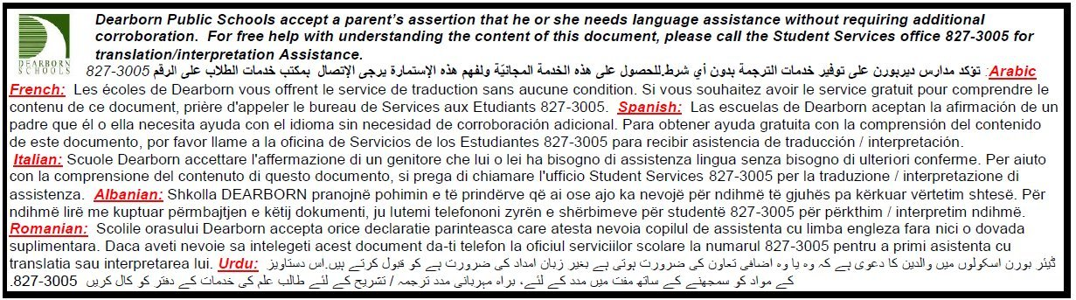

STUDENT ELIGIBILITY

Middle school students have a wide range of maturity levels. Some have the maturity to participate in a trip such as this one and some do not. For this reason, each student wishing to participate will be reviewed by the teachers. We will consider the following:

1. Attends school regularly.
2. Maintains an academic record in keeping with his/her ability.
3. Behaves in accordance with school standards of behavior as set forth in
the Dearborn Public Schools' Code of Conduct.

Any one of the following may result in the removal of the student from the trip:

1. Excessive unexcused absences.
2. Repeated suspensions from school (in and out of school suspensions).
3. A referral by a teacher who has concerns about a student such as behavior, attitude, etc.
4. An academic record that is concerning to teachers (low grades, low
homework turn-in rate, no effort, etc.).

Please understand that if a student is removed by the school, all efforts will be made to fill the vacancy; however, the cancellation policy will be used to determine the amount of the refund, if any, that will be given. You may forfeit all monies paid if the vacancy can not be filled.

Please read carefully and discuss with your child the rules of conduct, his/her responsibilities and the limitations of the school's responsibility.

RULES OF CONDUCT ON THE EDUCATIONAL TRIP

1. All students will conduct themselves in a manner which will reflect the highest
standards of the students and STEM Middle School. All articles on student
conduct set forth in the "Student Code of Conduct" will apply.

2. There will be NO smoking or possession of illegal materials during the entire trip.

3. Since this is a group function, EVERYONE must take part in ALL group
activities. No outsiders (those not officially on the trip) may take part in, or in
anyway be associated with, any trip activities, including those at the hotel.

4. Each student must be and stay in his/her OWN room by 10:00 PM to 7:00
AM. No outsider is to be permitted in any student's room at any time during
the trip (see no. 3 above).

5. It is understood that a violation of any rules set forth will be grounds for school
disciplinary action. This will be done at the discretion of the chaperones.

I have carefully read my son/daughter the above code and limitations.

We agree to the need for him/her to follow the code and rules completely and faithfully. I understand and agree with the school's limitations of responsibility.

By signing this form, I agree to the stipulations set forth above.

_________________________________ __________________________________
Student signature Parent signature

AS A PARENT OR GUARDIAN interested in having my child participate in a school trip, I agree that if my child breaks trip rules in a way that merits him/her being sent home from the trip, I will pay the fare home.

I fully understand that reasonable precautions will be taken to safeguard my child on this trip as are taken in all other school related activities, and I will not hold the Dearborn Board of Education, any other employees, or chaperones responsible for any accident or loss which might be sustained.

I give my child permission to participate in the school trip.

_____________________________________________ _____________________
(Parent or Guardian signature) (Date)

AS A STUDENT interested in participating in a school trip, I understand and agree that:

1. This is a school trip taken for educational purposes.

2. I will follow all school and trip rules.

3. I will have all schoolwork up-to-date before leaving.

____________________________________________ ______________________
(Student's signature) (Date)

The $445.00 trip cost, based on 8 students to a villa, can be paid in 3 installments. The first payment will be turned in to Ms. Fryzel with all enrollment forms by October 01, 2019.

PLEASE MAKE CHECKS PAYABLE TO CORPORATE TRAVEL.

