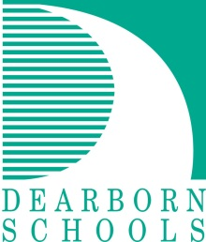Press Release #30/2016-2017

FOR IMMEDIATE RELEASE: April 21, 2017

Contact: Kurt Doelle, Teacher, Dearborn High School (313) 827- 1635

DoelleK@dearbornschools.org

David Mustonen, Director, Communications and Marketing (313) 827-3006

MustonD@dearbornschools.org

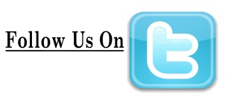



[www.DearbornSchools.org](http://www.DearbornSchools.org)

**Students First-**

***Inspire, Educate, Celebrate*** **Follow Us On**

**DHS Video Program**

**Premieres Student-Produced Films**

***- WDHS Film Festival Shorts April 27 and April 28; 6:30 p.m. doors open***

WDHS Video students from Dearborn High School welcome the public to attend the premiere screening of their newest short films on Thursday, April 27 and Friday, April 28. Doors to the Film Fest open at 6:30 p.m., films begin at 7 p.m. in the Michael A Guido Theater at the Ford Community & Performing Arts Center, 15801 Michigan Avenue, Dearborn, MI 48126.

Student-produced film titles making their debut include *Grandpa's List, Super Scrap, The Needle Drop, Wrong Place Wrong Time, More Punch, Lucidity*, and others.

The well-known video program at Dearborn High has a 30-year history. Over the years, students in the program have produced dozens of award winning sort and full-length films.

DHS Video Instructor Kurt Doelle noted, “These dedicated students write, shoot, cast, edit, and promote their projects with great creativity and enthusiasm.”

This year, current WDHS Video students will formally recognize DHS video program creator Russ Gibb, the now retired Dearborn High teacher and founder of the legendary Grande Ballroom.

Tickets to the WDHS Film Fest can be purchased in advance for $7 by calling   
(313)827-1635 or $8 online at [www.wdhsvideo.org](http://www.wdhsvideo.org). Same-day tickets are $10 at the Ford Community & Performing Arts Center Box Office.

###