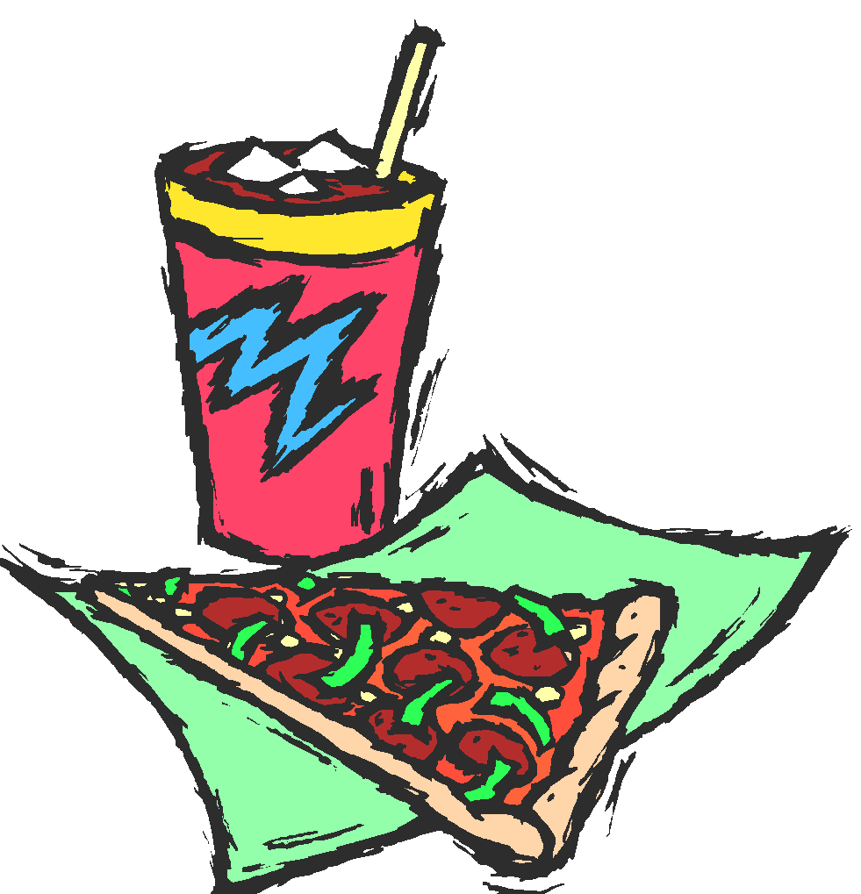

Attention All ‘DADS’ of
Snow School Students!

‘Dads and Kids’ Pizza Night Event!
FREE Pizza, Drinks and Fun!

Fathers and Father-figures,

On Wednesday, September 28 from 6:00 – 7:00 pm we will be having our 4th annual ‘Dads and Kids’ Pizza Night at our school. You will meet here at the school cafeteria at 6:00 pm for FREE pizza and drinks. At 6:30 we will have a presentation about our WATCH D.O.G.S.® (Dads Of Great Students) Program. WATCH D.O.G.S.® is an innovative program being used by schools across America which helps them to be positively impacted by the committed involvement of fathers and father-figures in their student’s life. Our goal is to have you spend at least one day this year at the school to be a positive male role model and to provide an extra set of eyes and ears.

Dads, granddads, uncles, step-dads and adult brothers . . . this is your chance to have a night out alone with your student in a fun atmosphere at school.

In order to participate, you need to do two things:
1. Fill out the bottom portion of this slip and return it with your student (ASAP) saying that you will attend the pizza night so we’ll have an accurate head count for the food.
2. Mark your calendars, and we’ll see you Wednesday, Sept. 28 from 6:00 – 7:00 pm.

_ _ _ _ _ _ _ _ _ _ _ _ _ _ _ _ _ _ _ _ _ _ _ _ _ _ _ _ _ _ _ _ _ _ _ _ _ _ _ _ _ _ _ _ _ _ _ _ _

___Yes!!! We’ll be there! (#) ___ of ‘Dad’ and students attending (no moms, please)

Father/Father-figure Name_______________________________ Email _____________________________________

Phone(s): Home ___ _________________ Mobile ______________________ Work ______________________

Student(s) Name ________________________________ Teacher’s Name _____________________________

Student(s) Name ________________________________ Teacher’s Name _____________________________

Student(s) Name ________________________________ Teacher’s Name _____________________________

