**Class of 2024 Freshman/Parent Orientation**

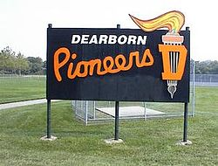

**Please join us on Wednesday, April 1st at 7 pm in the Dearborn High Auditorium to learn more about the academic programs, and extracurricular activities offered at DHS.**