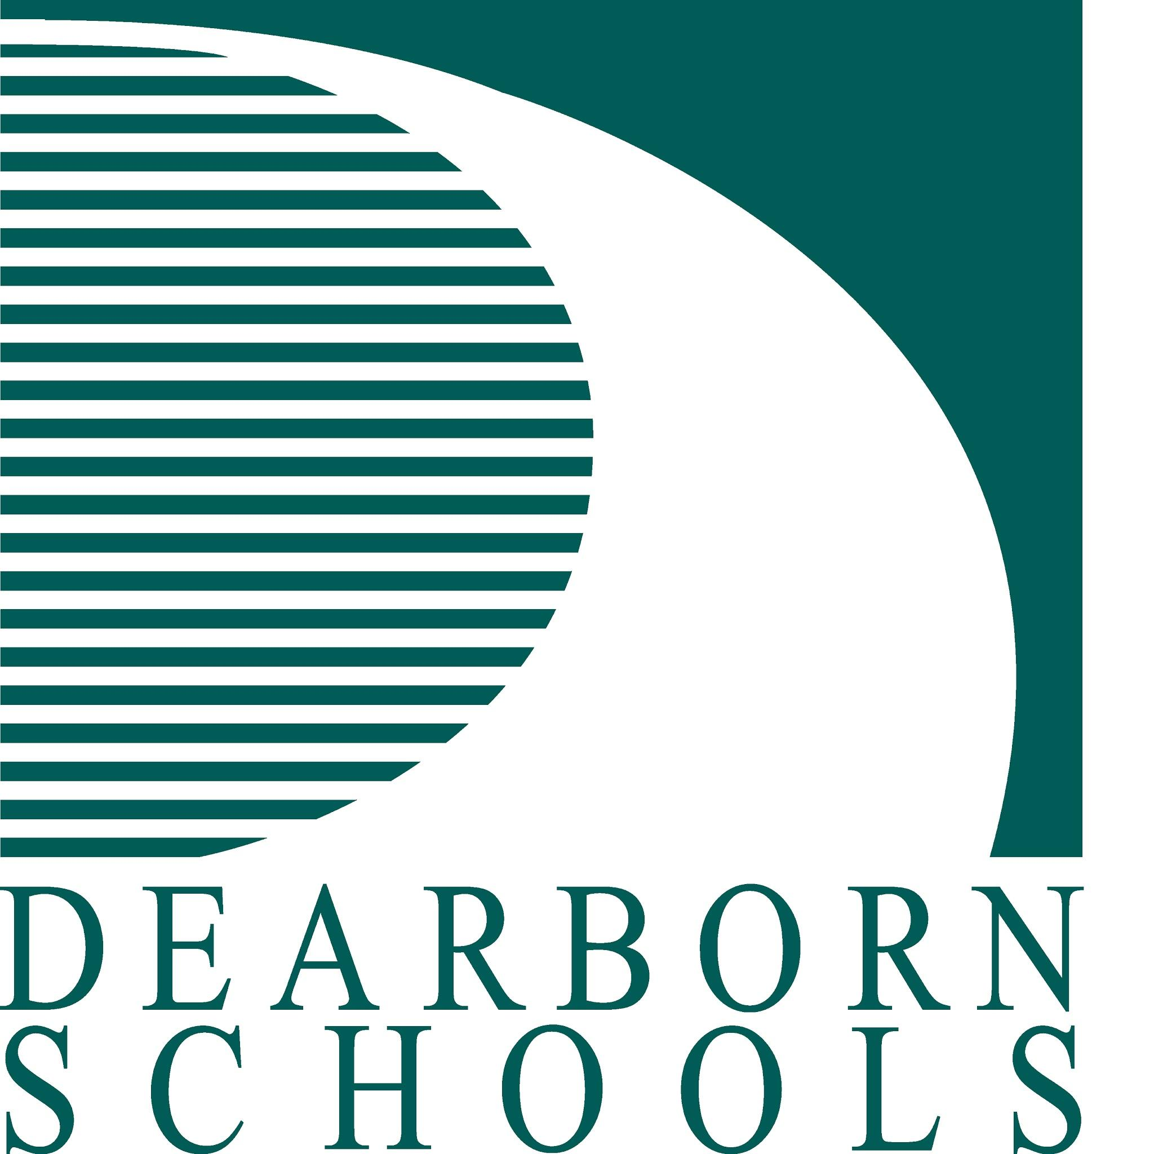

November 17, 2015

Dear Parents or Guardians:

We are all saddened by the tragic events that have occurred in Lebanon and Paris. I know for some these events have touched your life on a very personal level. On behalf of the Board of Education, I want to express my most sincere thoughts and prayers for all those who have become victims of these senseless acts.

As we continue to watch how these global events unfold, I want to assure you that our mission, to educate all students to high academic standards within a safe stimulating environment, will not change. Administrators, teachers, and staff will work to maintain an atmosphere conducive to teaching and learning in all of our schools. Current events will not control the school environment but, if applicable, could be part of a classroom discussion that is age appropriate and relates directly to the curriculum.

Please remember that you, as parents, have the biggest influence on your children. What you watch on television, read on the internet, and say in conversation are the thoughts and emotions your children bring with them to the classroom. Be aware of how they are feeling and reacting to the news stories of the day. In our world of twenty-four hour news channels and never ending coverage of tragic events, over exposure, especially in younger children, can be very harmful. Parents know their children best and are the people children trust the most with their thoughts and feelings. However, if you feel your child is overly stressed or emotionally upset about these or other world events, please share that information with your child’s teacher or principal.

I also want to assure parents that in the event of any type of local emergency, each school has developed an emergency plan unique to that school. The plan identifies key personnel, who in times of crisis, will assemble as an emergency management team to carry out an orderly response to any crisis situation. In addition, our district maintains an active relationship with the city of Dearborn Emergency Management department and will continue to follow its instructions and lead in the event of an emergency.

For those who have lived in this city for a while you are familiar with the type of national media attention our area can receive. For those of you who may be new to Dearborn I want to share with you that our city as a whole, is regarded as a nation model of how a community can work together to bring about understanding and build strong relationships.

The professionalism, learning, safety, and caring, that takes place in our schools to support students is our number one priority. By working together we will ensure our schools remain safe and focused on providing quality instruction to our students.

Thank you,
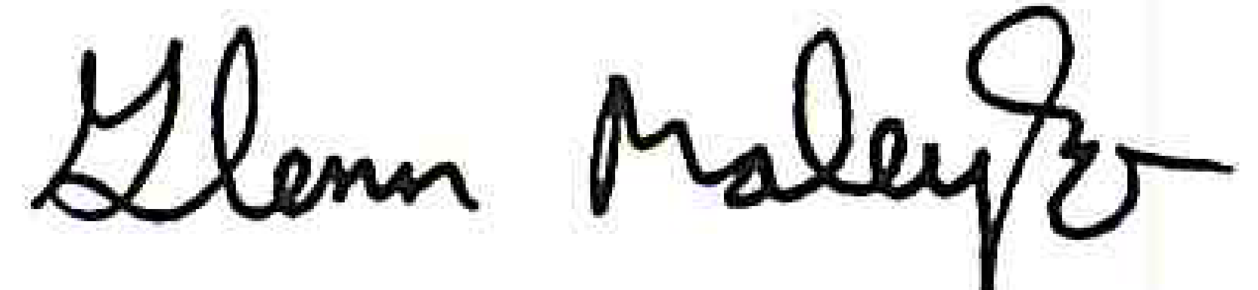
Glenn Maleyko, Ph.D.
Superintendent

