**Oakman Elementary**



[www.myon.com](http://www.myon.com)

myON Reader: Parent/Student Directions

Students and parents should use this packet to

view the books in the digital library.

**1.**

**Click on the red “Login now” button.**

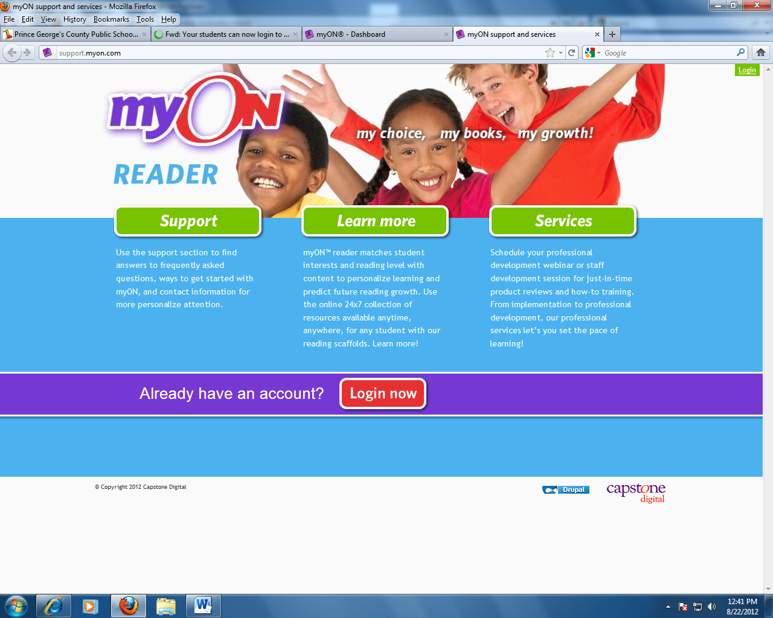

**3. Enter your date of birth “mmddyyyy” as the password. Please note the password is case sensitive and should be entered with all lowercase letters.**

**Example: 12082006**

**2. Username is your student ID**

**Example: 20040577**

**2.**

**1. Type Oakman Elementary in the School name box.**

**4. Click sign in.**

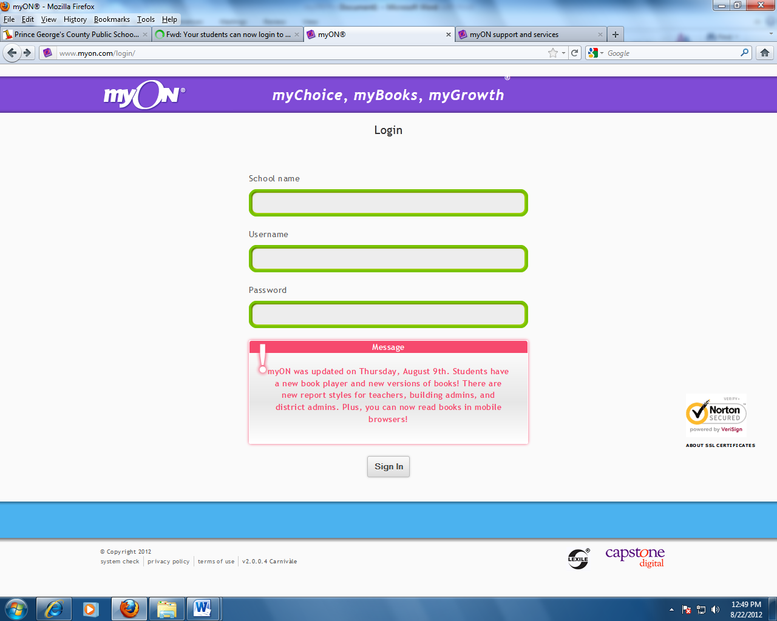

**This is the startup screen. From this screen, students are able to choose books to read based on genre, subject area, or interest.**

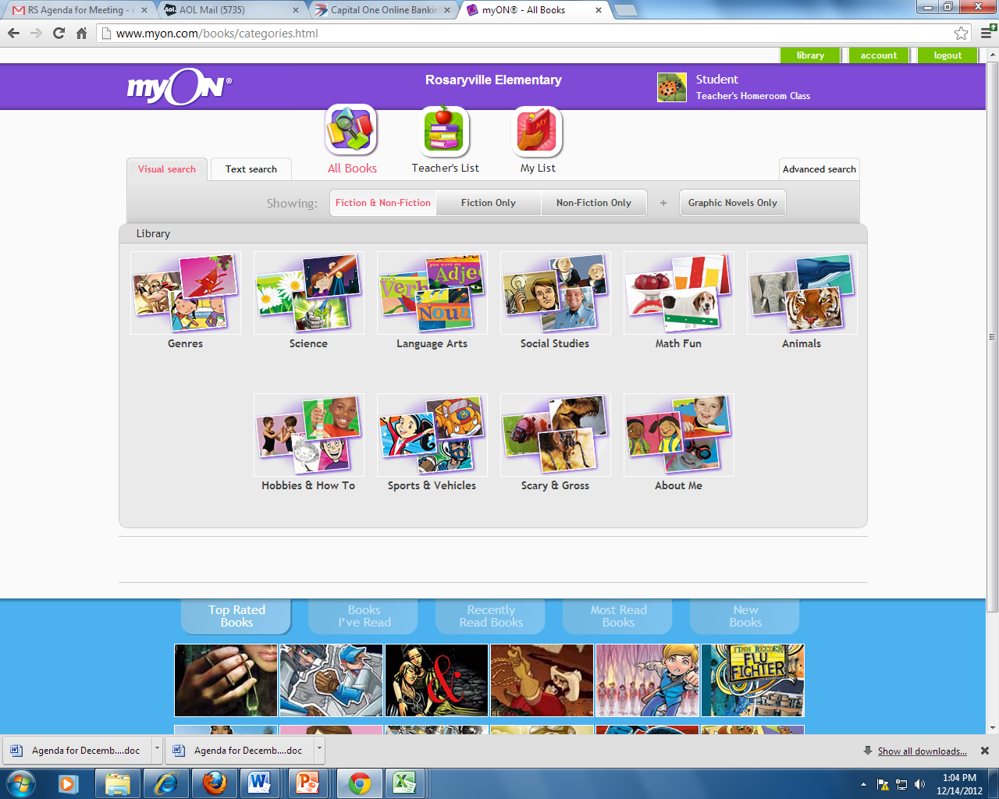

**Click on a category to view available books.**

**3.**

**4.**

**Students may also search for books on a particular topic they are interested in.**

**Click on a “Text Search” in order to activate the search bar.**

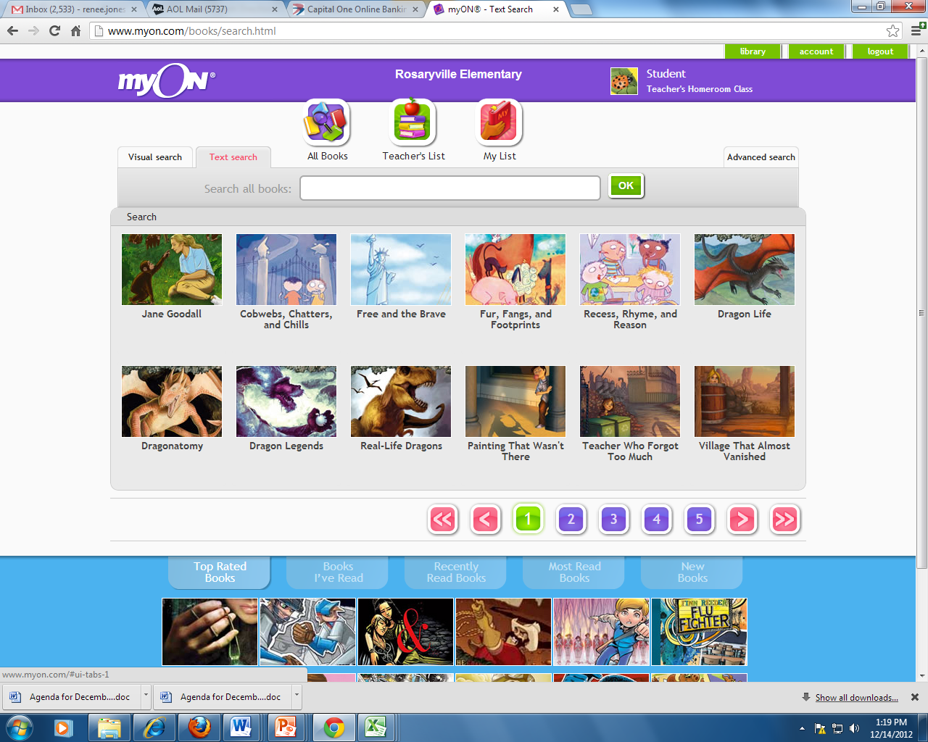

**Type a subject in the search bar and click “ok”.**

**A search for “dogs” brings up several books. Students are able to click on a book that they are interested in reading or peruse through the available titles until they find a book they like.**

**Click on one book to read.**

**5.**

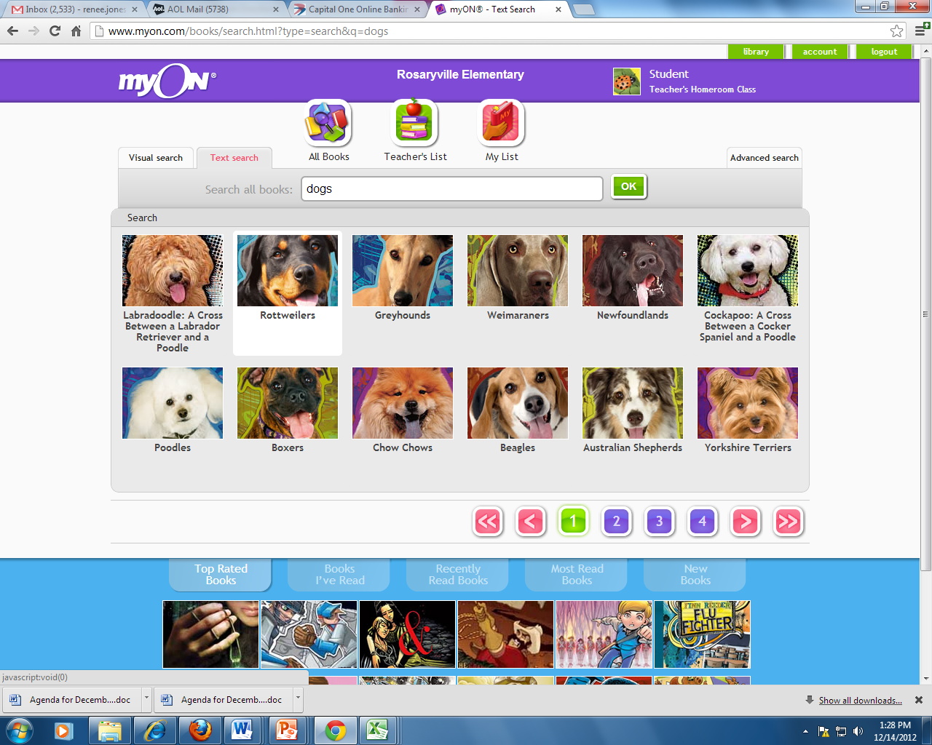

**Peruse through the selection of books by navigating through the pages of available titles.**

**Once students select a book, the book summary will appear. From this screen, students are also able to choose to read the book, search for more books like the one they chose or view information about the book.**

**Click here to search on more books on the same topic.**

**6.**

**Click here to learn more about the book. Information available include:**

* **Publisher**
* **Number of pages**
* **Lexile level**
* **Recommended grade level**
* **Copyright**

**Click “Read now” to begin reading the book.**

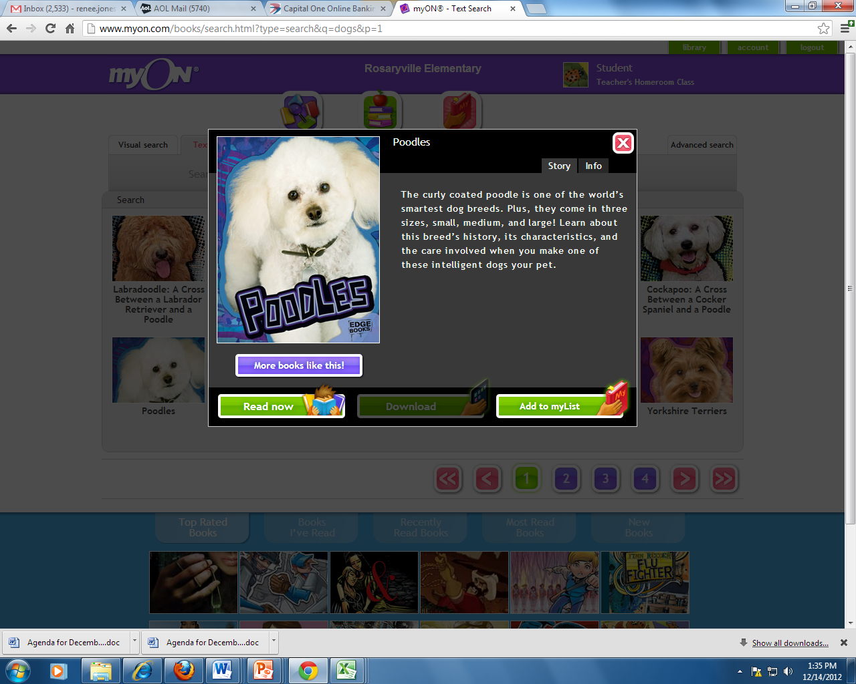

Happy reading!

Customer support is available at 1-888-728-1266.