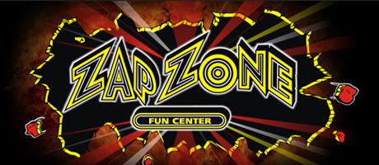

Have nowhere to go during Mid-Winter break? Oakman PTA has reserved Zap Zone on Monday February 17th for 3 hours of fun for only $20.00 per person from 3:00-6:00pm. You will get unlimited Laser tag, bumper cars, slime bucket, and the balladium. We had so much fun last year. Bring the whole family and come out and join us.
*Pizza and pop can also be purchased.
*for more information and to reserve your wristbands for entry please call
Batoul @ 313-721-3760
or
Amged @ 313-463-3623

