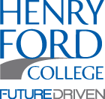
Henry Ford College
Children and Families Program Present:
“Turn Off the TV – Family Literacy Night”
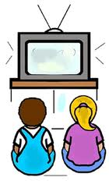
Promoting Family Literacy and Helping Families Strengthen Literacy in their Children’s Lives

Thursday, June 16th
^{5:30-7:30PM}
^{Henry Ford College Campus}
^{In the Student Center}
5101 Evergreen Rd. Dearborn, 48128

JOIN THE FUN! Open to the Public at no Cost
! Free Books!
*Family Story -Time *Hands-On Stations *Fun Games & Prizes for the Kids *Raffles
*Parent/Family Nutrition & Health Resources/Blood Pressure Checks
*Arts & Scrap Make & Take Table *Take a picture with Elmo, Mickey or a Minion!
*Face Painting *Literacy Baggies & Free Book: 12 mths-8 years old
Family “Get Up & Groove” Musical Entertainment-to close the event
Free Evening Kid Snacks, Popcorn & Parking!!
Please RSVP by Friday, June 10th: Let us know how many Adults/Children to expect!!
Contact Marlene White: Call (313)845-6311 Email – mwhite34@hfcc.edu

