

eEmployee

Registration and Password Reset

SMART: Product of Computer Services

Revised May 8, 2017

|  |
| --- |
| *THE WAYNE COUNTY REGIONAL EDUCATIONAL SERVICE AGENCY* |
| Board of Education • James S. Beri • Kenneth E. Berlinn • Mary E. Blackmon • Lynda S. Jackson • James Petrie • Randy A. Liepa, Ph.D., Superintendent |

# Register as a first time user

To sign on to eEmployee, you can either use your district’s link on their website

or log into:

**https:/hrweb.resa.net/eEmployee**



Start typing your district name in the District box. Select your district from the list that comes up.



Click on “Not a registered user?” to register the first time you log in to eEmployee.



Fill in your birth date and either your employee id number or the last 4 digits of your Social Security Number and click next.



You will then be prompted to set a password. The Password Policy requirements for your district will be listed. After keying in your password and confirming it, click next.



You will be directed back to the original log in screen. Log in using your new password.

If your districts Password Policy requires a security question, you will be prompted to set one up now. Using the dropdown, select a question, fill in your answer, and then click submit. Once your security password is set up, you are fully registered.

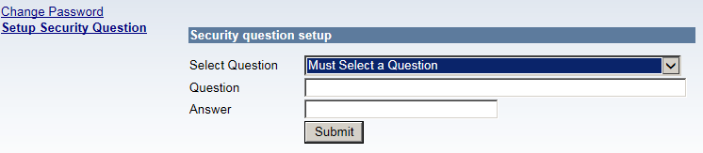

# Reset Password

**Employees**

From the login screen, fill in your District (start typing your district name in the District box and select your district from the list) and User ID and then click on “Forgot Password.”



You will then be prompted to set a password. The Password Policy requirements for your district will be listed. After keying in your password and confirming it, click next.

[Type a quote from the document or the summary of an interesting point. You can position the text box anywhere in the document. Use the Text Box Tools tab to change the formatting of the pull quote text box.]



You will be directed back to the original log in screen. Log in using your new password.

**Contractors**

If a contractor forgets the password, the Security Administrator will need to reset the password in the Security Module. Then, from the SMART login screen, type in the user name for both the User Id and the Password and you will be prompted to reset your password.

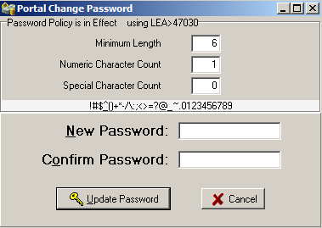

The Password Policy requirements for your district will be listed. After keying in your password and confirming it, click “update password”.