Dearborn Public Schools has partnered with American College of Education (ace.edu) to offer exclusive grants for continuing education programs that can help you meet your professional and personal career goals.

Grants vary by program of interest, and are as follows:

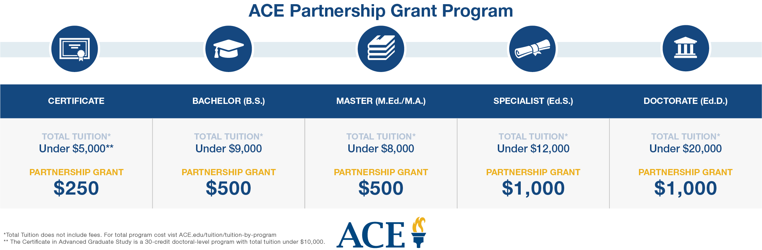

The Dearborn Public Schools Tuition Reduction Grant is open to all current employees who are ready to start a master’s, specialist or doctoral degree, or graduate certificate program at ACE. For those who do not wish to enroll in a Master’s or Doctoral Program, ACE also has STEM and TESOL certification programs along with classes that can help toward continuing education.

If you would like to know more about programs offered through ACE or are interested in the grant, then please contact Audrey Owens audrey.owens@ace.edu. You may also call her office phone at 1.833.230.6582.

