Madonna University Registration Form
Please completely fill in all the information requested
DATE | TERM /YEAR | SOCIAL SECURITY NUM BER | ID NUM BER

LAST NAME FIRST INITIAL

ADDRESS BIRTHDATE

CITY STATE ZIP PHONE: HOME ( ) CELL ( ) E-MAIL PLACE OF EMPLOYMENT WORK ( )
EMERGENCY CONTACT NAME PHONE ( )

ARE YOU: | Guest Student | Consortium Student
ARE YOU PURSUING: | Associate’s Degree | Bachelor’s Degree | Master’s Degree
 | Non-degree/General Courses |  | Major Area of Study
 | Undergraduate Certificate | Graduate Certificate | Teaching Certification for:
Have you been formally admitted to MU? Yes No Last Term Enrolled If No, see next section.

Non-Admitted and/or Non-degree seeking students: Students who have not been formally admitted to Madonna University, or wish to be re- admitted, must submit this form to either Undergraduate Admissions (Room 1001) or Graduate Admissions (Room 2414) for permission to register prior to actual registration. All credits earned while attending as a non-admitted and/or non-degree seeking student may or may not be applicable towards a degree at a later date. Financial Aid is not available for this status.

The following information is requested for Federal and State statistical purposes only. Responses are not required, but would be appreciated. Thank you. Gender: Male Female Religious Affiliation: Ethnicity: White-Non-Hispanic Am./Alaskan Indian Black-Non-Hispanic Hispanic Asian /Pacific Islander
Undeclared Foreign/Non-resident Citizenship First Language

On-Campus Participants, please use one of the following course numbers:
RDG 5510 HB-02-00: Reading Process, Assessment and Instruction for Elementary Teachers (3 SH)
RDG 5520 HB-02-00: Reading Process, assessment and Instruction for Secondary Teachers (3 SH)

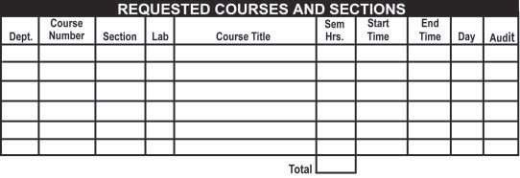
Processing of this form charges a nonrefundable Registration fee.

Advisor Signature | Date |  | Admissions Officer | Date |  | Student Signature | Date
(Required for provisionally admitted) |  |  | (Required for non-admitted/non-degree

MAIL TO:
seeking students requiring permission to register)
Madonna University • Attn: Janice Centers
36600 Schoolcraft Road • Livonia, MI 48150

Office Use:

