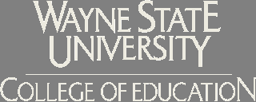
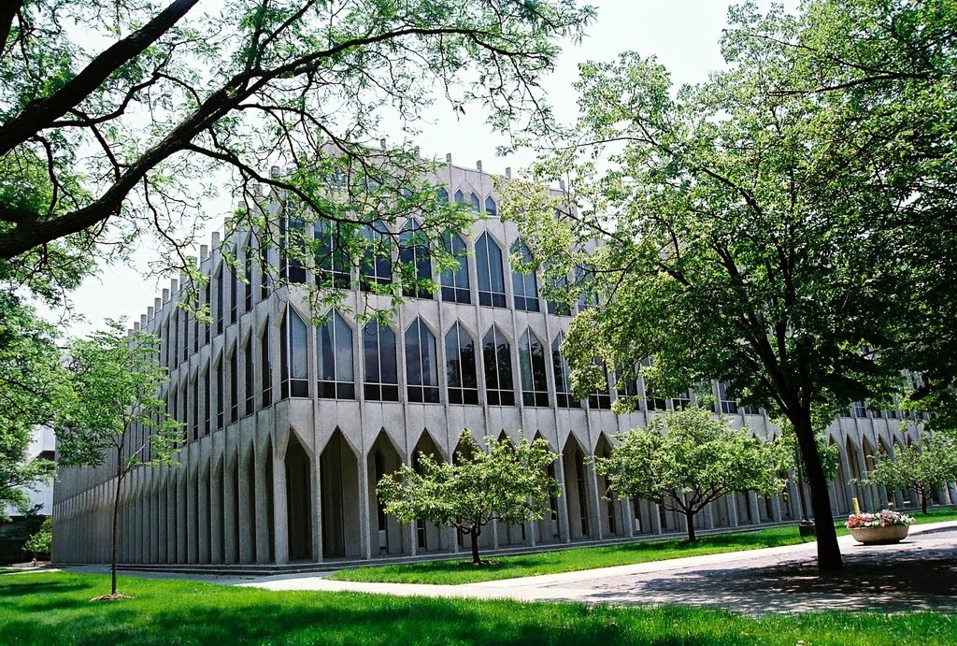
Interested in joining the new Wayne State University/ Crestwood/Melvindale ESL Endorsement Cohort?

The College of Education at Wayne State University is pleased to announce a $2,500.00 scholarship opportunity for the first 12 students accepted into the M.Ed. ESL endorsement cohort program for Melvindale and Crestwood School District teachers during the 2015-2016 academic year.

Scholarships will be awarded on a first come, first served basis for all teachers admitted to the Melvindale/Crestwood M.Ed (ESL) program cohort between June 1, 2015 and August 20, 2015.

Scholarship funds must be used in the 2015-16 academic year. Each recipient will receive $1,000.00 in the Fall ‘15 semester, $500.00 for the Winter ‘16 semester, and another $1,000.00 for the Spring ‘16 semester.

This is not a reimbursement program. Students who receive a scholarship and register for a WCS cohort class will have the scholarship amount deducted from their tuition bills. Early class registration is critical; those who register late are not guaranteed prompt application of scholarship funds.

Classes must be taken at Melvindale or Crestwood schools. Students have the option of taking additional classes at Dearborn Public Schools, WSU’s main campus, or online, but they must also be concurrently registered for Melvindale/Crestwood classes.

This funding opportunity is available to any in-service teacher employed in a Wayne County school district, who applies to the program and becomes part of the WSU/Crestwood/Melvindale ESL endorsement cohort experience. There are only 12 scholarships available.

Once you are accepted into the program, please email Dr. Elizabeth Hopkins (elizabeth.hopkins@wayne.edu) so your name can be added to the scholarship list if slots are still available.

***

For more information about the cohort or the scholarship, please contact:

Dr. Elizabeth Corah-Hopkins
Program Coordinator, Bilingual/Bicultural Education, Wayne State University
elizabeth.hopkins@wayne.edu

Apply to Wayne State online at coe.wayne.edu. Classes start September 2!

