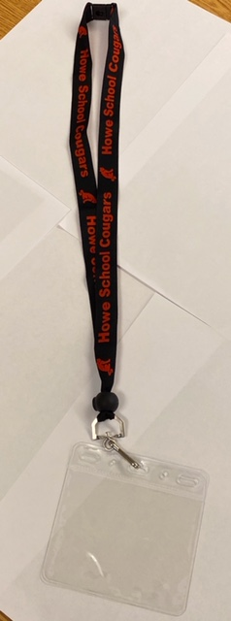

**$5.00 each!**

**Includes ID holder**

**Student Name: _________________**

**Teacher: _________________**

**Number of Lanyards: _________________**

**\*\*Please return all money and order forms in an envelope to Mr. Hesch’s mailbox\*\***

**Mr. Hesch’s class is selling Howe School lanyards!**

**All proceeds will benefit the classroom cooking program here at Howe!**

**Lanyard Fundraiser!**