Howe Spirit Wear Order Form
Support your school & order your Howe Spirit Wear for field trips! Fill out the form below with payment & return to your child’s teacher by Wednesday, October 17th!!

Student Name: _________________________________________ Grade: _________
Phone #: _____________________Email: ___________________________________
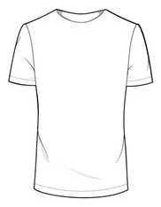
CHILD SIZES
ITEM | PRICE | COLOR | SIZE | QUANTITY
T-shirt | $10.00 | Red | XS S M L XL
Long Sleeved T-shirt | $15.00 | Red Black | XS S M L XL
Soccer shirt  (short sleeves) | $20.00 | Red | XS S M L XL
Hooded Sweatshirt | $25.00 | Red Black | XS S M L XL
Zipper Hoodie | $30.00 | Red Black | XS S M L XL
TOTAL # OF CHILD ITEMS: __________ TOTAL COST: _____________
T-shirt &
Long Sleeve T
White logo

Soccer shirt
Red/black
White logo

Red/black

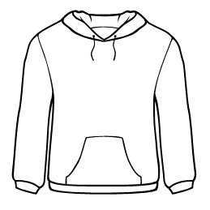
ADULT SIZES
Hooded Sweatshirt
& Zipper Hoodie
White logo

ITEM | PRICE | COLOR | SIZE | QUANTITY
T-shirt | $10.00 | Red | XS S M L XL
Long Sleeved T-shirt | $15.00 | Red Black | XS S M L XL
Soccer shirt  (short sleeves) | $20.00 | Red | XS S M L XL
Hooded Sweatshirt | $25.00 | Red Black | XS S M L XL
Zipper Hoodie | $30.00 | Red Black | XS S M L XL
TOTAL # OF ADULT ITEMS: _______________ TOTAL COST: _____________

TOTAL # OF ITEMS: _________ TOTAL COST: $_____________ □ CASH □ CHECK #______
*Orders will be placed on Friday, Oct. 19th (make checks payable to Howe PTA)

