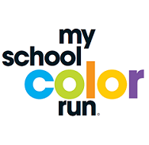



color,fun and.. fundraising

**1st annual Howard Dragon’s Color Fun Run!**

**Register by 4/13/18 to guarantee a race bib, color packet, and t-shirt!**

**The run will be held at Howard Elementary School at 9am!**

**Howard Elementary School on April 28th, 2018**

**My School Color Run is an exciting fundraising event where participants are doused with color while raising funds!**

**Register online! Events.myschoolcolorrun.com**

**UNTIMED 5k and 1mile COLOR FUN RUN FOR ALL!**