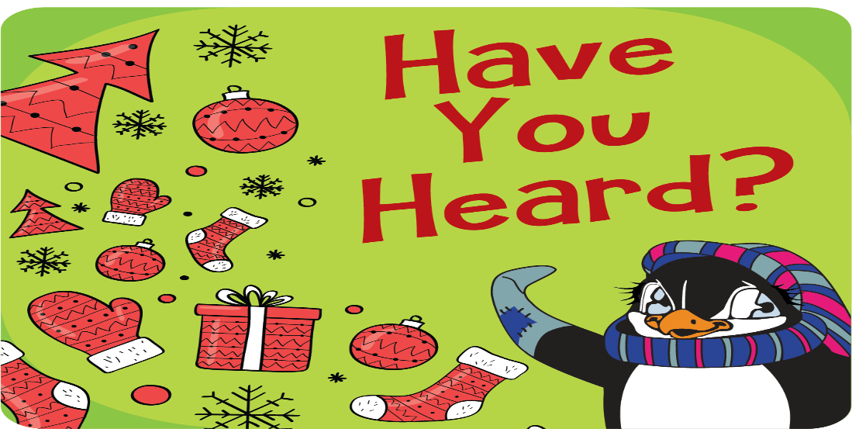

Dear Parents,
We know that so much about this school year looks different, but we're so excited that our school will be participating in an online Penguin Patch® Holiday Shop to spread holiday cheer!
Penguin Patch® Holiday Shop is a fun way for students to shop for family members and experience the spirit of giving while learning to earn, budget, and save! Our online shop will be open November 23rd and end December 4th.
To log in to our school's secure shopping platform, please use this link:
shop.penguinpatch.com.
Your student will have over 100 delightful gifts to choose from, all ranging in price from $0.50 to $12. This is an amazing opportunity to empower your student to choose, purchase, and give gifts to their loved ones! Remember, a portion of every dollar spent goes back to our school, so when your child shops the school also receives funds!
All gifts will be shipped straight to your home for a small flat-fee. They'll arrive in festive "Special Delivery" packaging, with wrapping supplies included! We're excited to create this new holiday tradition and spread good cheer with you!
Happy Shopping!
Mrs. Jones,
Penguin Patch Holiday Shop Chairperson

