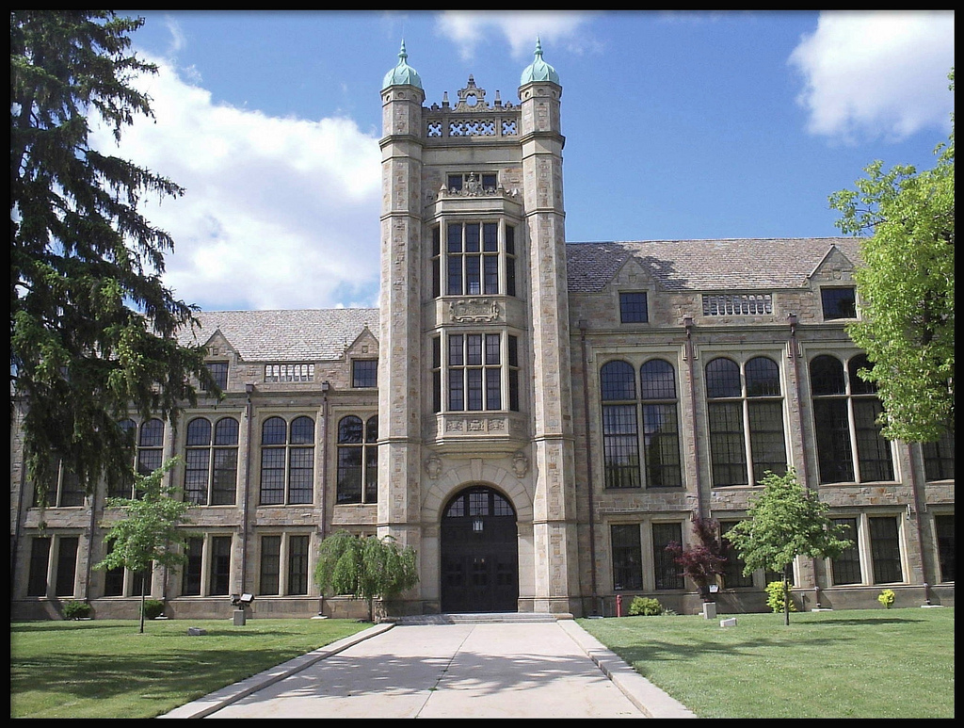
FORDSON HIGH SCHOOL
2018 Talent Show

Friday, December 14, 2018

Doors open: 6:30
Show starts: 7:00pm

Tickets on sale pre-sale: $10
At the door: $15
See Mrs. Zriek (A200) or
Mrs. Ayoub (A 102)

