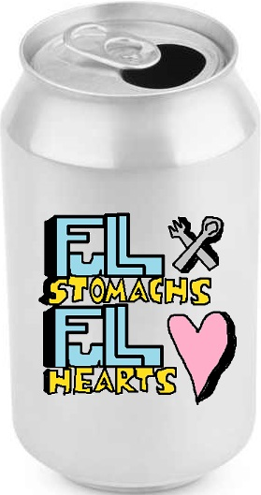
CHRISTMAS FUNDRAISER

- FEED A HOMELESS SHELTER FOR CHRISTMAS!
- RAISE MONEY FOR GIFTS FOR THE KIDS IN THE CHILDREN’S HOSPITAL FOR CHRISTMAS!
- BRING IN YOUR EMPTY POP BOTTLES OR POP CANS STARTING NOVEMBER 9TH AND ENDING DECEMBER 4TH. PLACE THEM IN THE GIANT POP CANS IN THE CAFETERIA. YOU CAN ALSO DONATE MONEY THROUGH GOFUNDME AT gofund.me/r38gqfqs
- BRING SMILES AND JOY TO THE ONES WHO NEED THEM THIS HOLIDAY!

