CREATING YOUR STUDENT ACCOUNT

Have students Log into their Dearborn Schools Account and under Useful Links choose Clever.
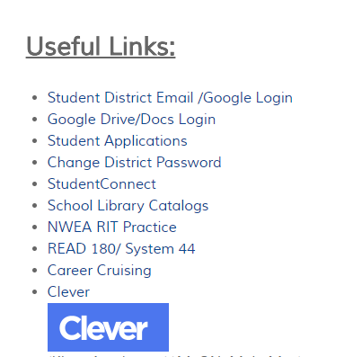

If prompted, click Log in with Google.
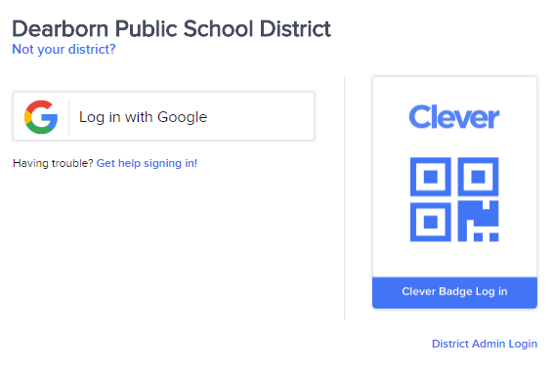

Click Khan Academy
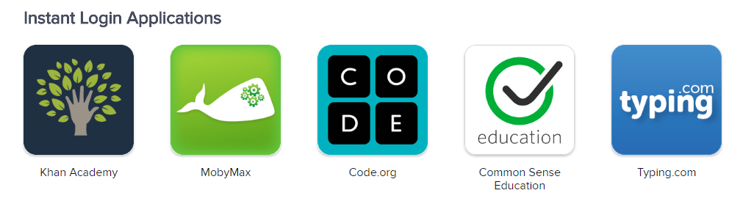

If students already have an account they will be taken to the home page, if not, they will see the screens below. They should automatically be assigned grade and subjects, if not have them choose appropriately then click continue.
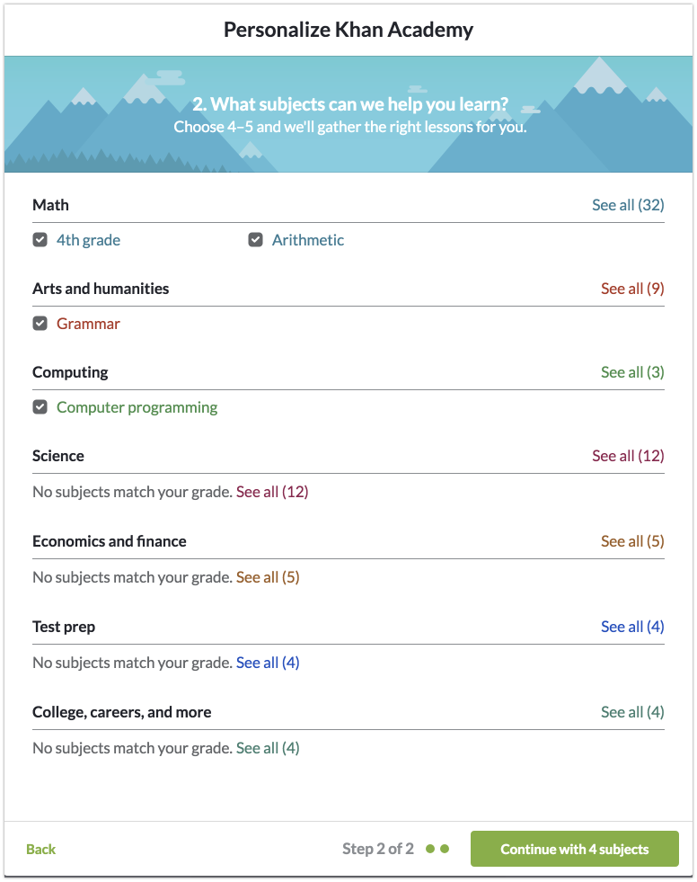
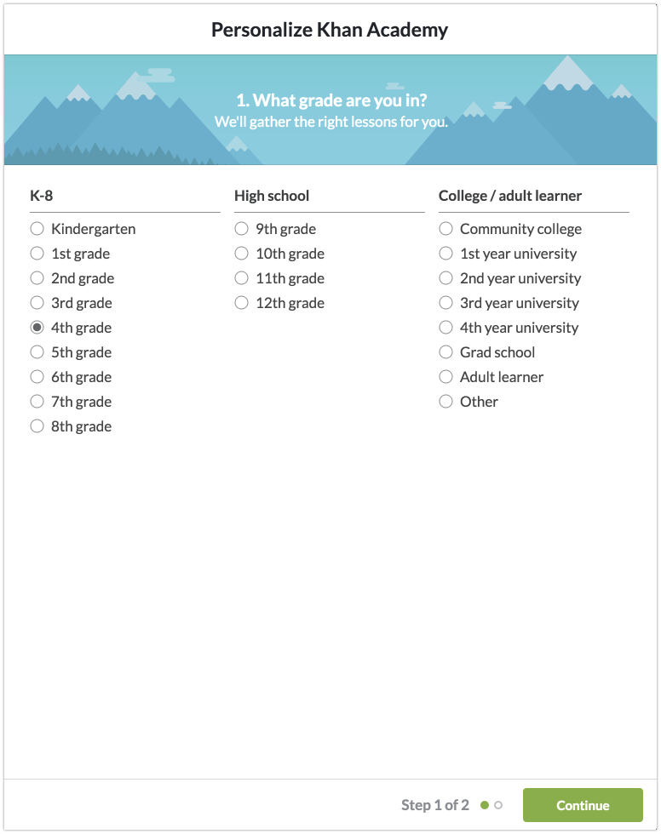

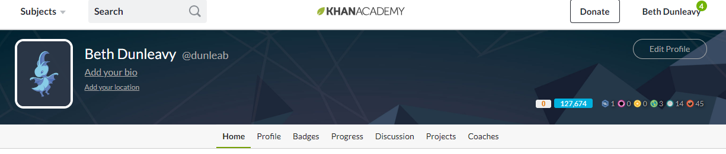
Once students get to the home page, they will type map in the search bar and click enter.

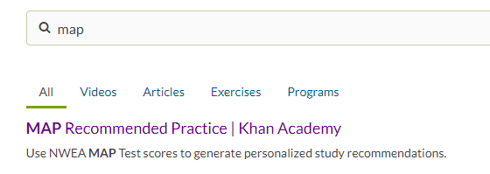
Choose Map Recommended Practice. Students must do this every time they log in.

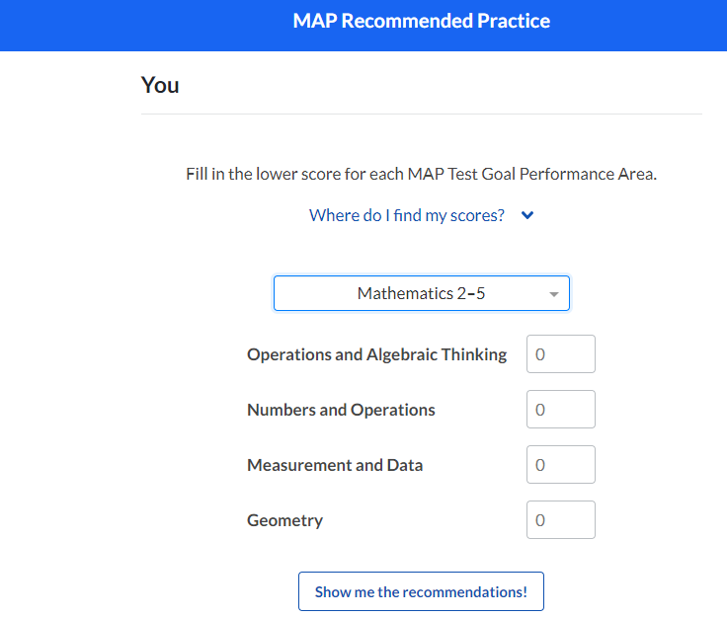
The first time students login they will have to add their NWEA scores. Make sure they have chosen the appropriate test and enter the lower score for each area. Then they will choose Show me the recommendations.

Every time students login through Clever they need to put map in the search bar and choose Map Recommended Practice.
Students only need to put scores in once.
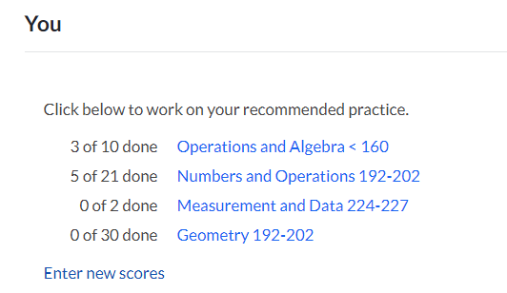
They can choose any of the areas they would like to work on and click that topic.

They can then begin practicing any of the skills in that domain by clicking practice. It is recommended that they start at the top and work down as skills build on each other.
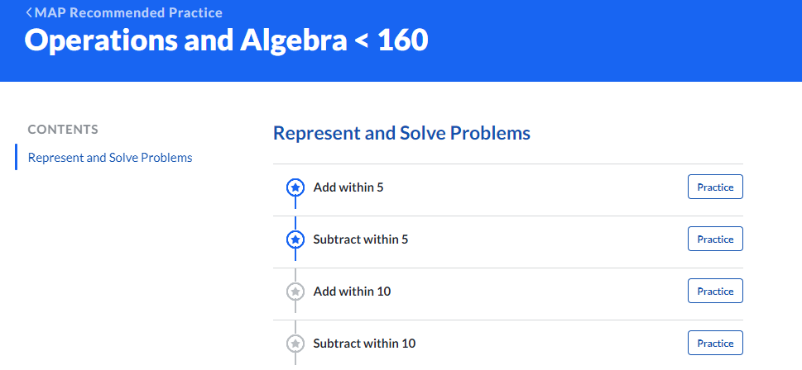

Students are expected to practice 60 minutes per week over the summer. Only these practices will count. IF they watch videos to help them complete these practices, these minutes will not count. They MUST work on the MAP practices to get summer learning credit.
Thank you for your help getting 5th graders signed up. If you give them some time before the end of the school year to start practicing that would be very helpful. Minutes will begin counting June 1, so any work they do with you between June 1 and June 14 will count toward their summer learning.
If you have any questions please call the help desk at 827-3003.

