District Improvement Goals  - All students will increase in reading and writing proficiency across the content areas.  - All students will increase in math proficiency  across the content areas.  - All students will increase proficiency in science  and social studies across the content areas.  School Improvement Goals  - All students will read and comprehend text  across the content areas  - All students at Iris Becker Elementary will become proficient writers.  - All students at Iris Becker Elementary will increase proficiency in Math.  Students set personal learning goals to help them succeed in school and in life.  These are my learning goals for this year:  My academic, social and/or personal goals:  - ______________________________________________________________________  - ______________________________________________________________________  - ______________________________________________________________________  My teacher can help me by:  - ______________________________________________________________________  - ______________________________________________________________________  My parents can help me by:  - ______________________________________________________________________  - ______________________________________________________________________ | Points of Pride, Assessment Results  - Michigan Department of Education Reward School for 2012, 2013 & 2014 for Beating the Odds and High Progress  - #2 ranking by the Mackinac Center for Public Policy, 2013 & 2014  - Wayne County Evergreen School, 2014 & 2015  - All Becker Classroom Teachers have a Bilingual or ESL Endorsement, or are currently working towards that endorsement.  - The entire staff is highly qualified and trained, and professional development is ongoing. Becker’s staff often provides Professional Development for the district.  - Strong Leadership Team consisting of the Principal, Literacy Coach, Bilingual Resource Teacher and Teacher Consultant.  - #4 ranking in MEAP reading in 3rd grade, 2013, #1 ranking in MEAP math in 3rd grade, 2013  - Becker’s MEAP scores are always above district, ISD, and state in most content areas.  - Becker’s ELL 3rd grade students scored above 3rd grade aggregate score for the district, Becker’s ELL students always outscore district ELL students in all content areas  - Becker participates in community service programs, including: Down Syndrome Guild of SE Michigan, Healthy Living Program, Children with Hairloss, IICD Michigan Clothes Collection, Sweet Dreamz, Autism Alliance of Michigan.  - MDE Partnership with Holbrook Elementary in Hamtramck, Michigan.  - Becker offers many extra-curricular activities including; Peer Mediation, chess, cross-country, service and safety patrol, Ski Trip, Girl Scouts and fifth grade science camp. | In the Classroom  Iris Becker Elementary staff works with students and their families to support student success in reading, writing, and math.  - Small group instruction in all content areas  - Daily 5  - Math Workshop  - Eight Math Practices  - School-wide strategies  - Writing Block  - Interventionist/IC/resource staff support  - Modeling/Co-Teaching  - RTI/MTSS team  Bridging Home & School  Iris Becker staff members work closely with parents to build strong relationships.  - Parent/student expectation meeting  - Parent-Student-Teacher conferences  - Student/Parent Compact  - Monthly Hands-on parent meetings  - Educational Parenting Workshops  - PTA meetings  - Volunteering in the classroom/activities  - Homework Helper  - Extended Day  - Open House  - Literacy, Math & Science Nights  - Open-Door Policy  - Phone Calls  - Home Visits  - International Festival  - Fine Arts Night  Bridge Magazine Academic Champions

What is a School-Parent Compact?  A School-Parent compact is an agreement that parents, students, and school staff develop together. The compact explains how parents, students and teachers work together to improve student success and achieve improvement goals.  Effective compacts link to goals of the school improvement plan, focus on student learning skills, describe how teachers will help students develop those skills using high-quality instruction, share strategies parents can use at home, explain how parents and teachers will communicate about progress, and describe opportunities for parents to become meaningfully involved in their child’s education.  Parents and staff work together to develop School-Parent Compacts. Teachers suggest home learning strategies, parents add ideas to make them more specific, and students tell us what will help them learn. Meetings are held every year to review the Compact and make changes based on student needs.  Parents can contribute comments at any time. Please send comments or concerns directly to your school principal.  Dearborn Public School Reports/Downloads  http://dearbornschools.org/downloads/ annual-education-reports | Building Partnerships  Iris Becker will communicate with parents, students, and teachers through a multitude of ways:  - Parent-Teacher Conferences  - Literacy, Science and Math Nights  - Volunteer Opportunities  - Fantastic Fathers  - Monthly “Make-it, Take-it” Parent Meetings  - Active PTA Hosting Family Events  - Parenting Classes  - Monthly Newsletter  - Robo-Calls  - Teacher and School Blogs  - Grade Level Meetings  - Parent and student representation on the  SIP team and March is Reading Month  - Student/Adult Mentor Program  Summarize Major Assessments  - M-Step (3rd, 4th, 5th)  - NWEA in ELA, Math, & Science (3-5)  - Common Assessments in Social Studies  - K-2 Performance Tasks in Science  - End of Unit Assessments  - Classroom Assignments & Projects  - DRA II  Specific initiatives include:  - Small group focused instruction/strategy groups in all content areas.  - Student engagement/discussion promoting oral language.  - Technology integration for lesson delivery and across all content areas.  - Student Goal Setting and High Expectations  - Math Workshop model in all classrooms.  - R.A.N. and Close Reading in content areas, as well as staff professional development. | Iris Becker Elementary School  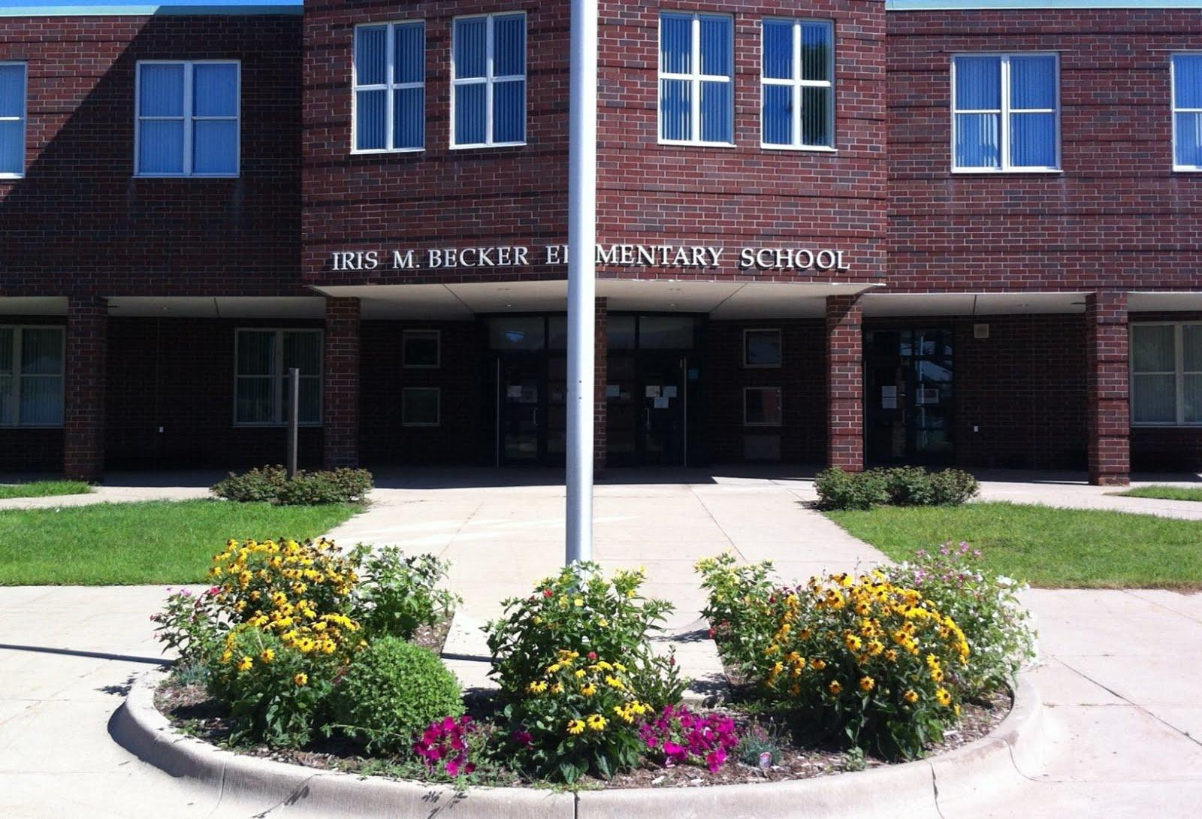  Michigan Department of Education Reward School  Ranked #2 by the Mackinac Center for Public Policy, 2014 & 2015  Wayne County Evergreen School for 2015  David Higgins, Principal  10821 Henson  Dearborn, MI 48126  (313) 827-6950  http://becker.dearbornschools.org/  Mission Statement  The mission of Iris Becker Elementary School, in partnership with parents and the community, is to provide a variety of intellectual, emotional, social and physical experiences that will produce educated, motivated and responsible citizens.  Becker Elementary…We are Family!

